15IT304J- Project Report

Online Food Ordering System

# Team Members:

1. Animesh Srivastava- RA1711003010823
2. Mihir Verma- RA1711003011001
3. Prashant Verma- RA1711003011031

Introduction

**Online food ordering** is the process of ordering food from a website .The product can be either ready-to-eat food (e.g., direct from a certified home-kitchen, restaurant) or food that has not been specially prepared for direction consumption (e.g., vegetables direct from a farm/garden, frozen meats. etc).The aim of developing Online Food Ordering system project is to replace the traditional way of taking orders with computerized system. Another important reason for developing this project is to prepare order summary reports quickly and in correct format at any point of time when required.

Online Food Ordering System has a very lot of scope. This PHP project can be used by any restaurants or fast foods for customers for keeping their order records. This project is easy, fast and accurate. It requires less disk space. Online Food Ordering System uses MYSQL Server as backend so there is not any chance of data loss or data security. A customer can choose to have the food delivered or for pick-up. The process consists of a customer choosing the restaurant of their choice, scanning the menu items, choosing an item, and finally choosing for pick-up or delivery. Payment is then administered by paying with a credit card or debit card through the app or website or in cash at the restaurant when going to pickup. The website and app inform the customer of the food quality, duration of food preparation, and when the food is ready for pick-up or the amount of time it will take for delivery.

# 1.1 Objective

The main objective of this system is to manage the details of item category, food, delivery address, order, and shopping cart. It manages all the information about item category, customer, shopping cart, item category. The project is totally built at administrative end and thus only the administrator is guaranteed the access. The purpose is to build and application program to reduce the managing the item category, food customers. It tracks all he delivery address ordered.

# Needs of Online Food Order

Helps customer to order their food at any time. The customers will be able to order their favorite dishes at any point of time, and as we have pointed out earlier, that time is a minimal option, and restaurants must have a specified system through which they can serve a huge number of customers while making their work smoother. Ordering.co is one of the best platforms which provides all of these platforms along with numerous innovative features which has turned countless small and large businesses into an inspiring leader in the online marketplace.

System Requirements

# HARDWARE REQUIREMENTS

1. Intel Pentium Processor or above.
2. 4GB RAM
3. 1 GB free disk space.

# SOFTWARE REQUIREMENTS

1. Windows Version7.0 or above.
2. Php Version 6.0 or above.
3. Xampp/ Wamp Server.
4. Text Editor. Eg- Notepad++, Atom, Sublime

System Architecture

# Methodology Development Model

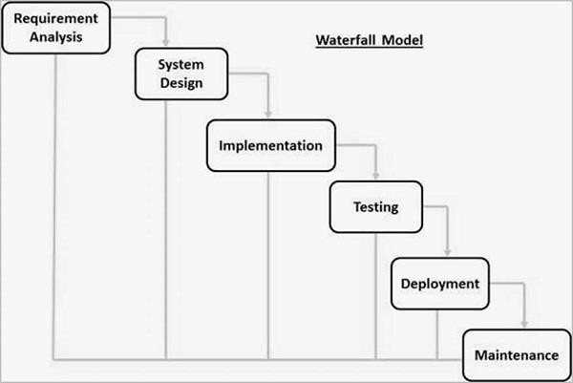

The sequential phases in Waterfall model are −

**Requirement Gathering and analysis** − All possible requirements of the system to be developed are captured in this phase and documented in a requirement specification document.

* + - **System Design** − The requirement specifications from first phase are studied in this phase and the system design is prepared. This system design helps in specifying hardware and system requirements and helps in defining the overall system architecture.
    - **Implementation** − With inputs from the system design, the system is first developed in small programs called units, which are integrated in the next phase. Each unit is developed and tested for its functionality, which is referred to as Unit Testing.
    - **Integration and Testing** − All the units developed in the implementation phase are integrated into a system after testing of each unit. Post integration the entire system is tested for any faults and failures.
    - **Deployment of system** − Once the functional and non-functional testing is done; the product is deployed in the customer environment or released into the market.
    - **Maintenance** − There are some issues which come up in the client environment. To fix those issues, patches are released. Also to enhance the product some better versions are released. Maintenance is done to deliver these changes in the customer environment

Type of users/Actors

1. Admin
2. Vendor
3. Customer

### Admin Features

1. Login
2. Manage Vendors
3. Manage Vendors Products/Food
4. Manage Customers
5. Manage Food Order details
6. Manage Payment details and Wallet

### Vendor Features

1. Create account
2. Login
3. Add Food details
4. Update Food details
5. Delete Food
6. Check food order
7. Update food delivery status

### Customer Features

1. View Food details
2. Register/Create Account
3. Login
4. Add to cart
5. Update Cart
6. Checkout
7. Pay Using Wallet
8. Check Food delivery status

# Specification Requirement

## External Interfaces

- This interface will be actual interface through which the user will communication with the application and perform the desired tasks.

Admin login

### ID:

**Role**: Admin wishes to login to the system

**Precondition**: Username and Password

**Success end Condition**: Main option of screen display

**Failed end Condition**: User has entered incorrect Username and Password or both

Edit

### ID:

**Precondition:** User has successfully navigated to the search result

**Success end Condition:** User has successfully made the changes

1. To edit user records in the data base, first search the record you want to edit then click on ‘edit’ button.
2. Edit the particulars user that you want to change and click on’ Save’ button.

Online Food Order

Login Information System

* Description

-The system will maintain the login information of its user to enter in to the software

* Validating Checks

-Administrator need to login the unique id and password.

-Contact number should have maximum 10 digits.

-All the details must be fill up.

-Email address should be in the proper format.

* Sequencing information

-Login information should be filled before the user allowed.

* Error Handling

-If user doesn’t filled up validate information then the system display error message for user and request to enter the validate information.

Performance required

* Security

-System should be Protected from unauthorized access Where the validate Username and Password are required so no other can access.

* Maintainability

-System should be design in a maintain order. So it can be easily modified.

Data Model:

A database model is a type of data model that determines the logical structure of a database and fundamentally determines in which manner data can be stored, organized and manipulated.

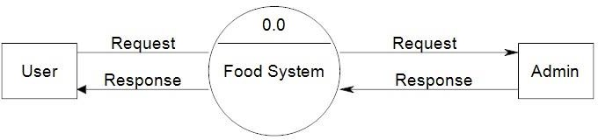Figure: Data flow

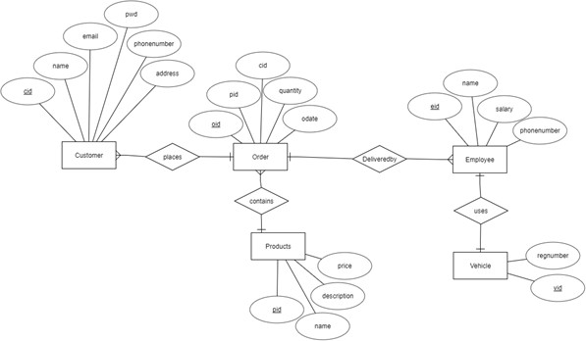

ER Diagram

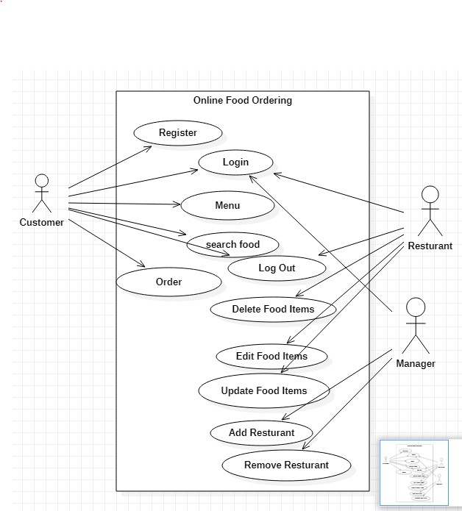

Use Case Diagram

Implementation

<?php

session_start();

if(isset($_SESSION['admin_sid']) || isset($_SESSION['customer_sid']))

{

header("location:index.php");

}

else{

?>

<!DOCTYPE html>

<html lang="en">

<head>

<meta http-equiv="Content-Type" content="text/html; charset=UTF-8">

<meta name="viewport" content="width=device-width, initial-scale=1, maximum-scale=1.0, user-scalable=no">

<meta http-equiv="X-UA-Compatible" content="IE=edge">

<meta name="msapplication-tap-highlight" content="no">

<title>Login</title>

<link href="https://fonts.googleapis.com/css2?family=Libre+Baskerville&display=swap" rel="stylesheet">

<!-- Favicons-->

<link rel="icon" href="images/favicon/favicon-32x32.png" sizes="32x32">

<!-- Favicons-->

<link rel="apple-touch-icon-precomposed" href="images/favicon/apple-touch-icon-152x152.png">

<!-- For iPhone -->

<meta name="msapplication-TileColor" content="#00bcd4">

<meta name="msapplication-TileImage" content="images/favicon/mstile-144x144.png">

<!-- For Windows Phone -->

<!-- CORE CSS-->

<link href="css/materialize.min.css" type="text/css" rel="stylesheet" media="screen,projection">

<link href="css/style.min.css" type="text/css" rel="stylesheet" media="screen,projection">

<!-- Custome CSS-->

<link href="css/custom/custom.min.css" type="text/css" rel="stylesheet" media="screen,projection">

<link href="css/layouts/page-center.css" type="text/css" rel="stylesheet" media="screen,projection">

<!-- INCLUDED PLUGIN CSS ON THIS PAGE -->

<link href="js/plugins/perfect-scrollbar/perfect-scrollbar.css" type="text/css" rel="stylesheet" media="screen,projection">

<style>

body{

font-family: 'Libre Baskerville', serif;

color: black;

background-image: url("food.jpg")

}

</style>

</head>

<body>

<!-- Start Page Loading -->

<div id="loader-wrapper">

<div id="loader"></div>

<div class="loader-section section-left"></div>

<div class="loader-section section-right"></div>

</div>

<!-- End Page Loading -->

<div id="login-page" class="row">

<div class="col s12 z-depth-4 card-panel">

<form method="post" action="routers/router.php" class="login-form" id="form">

<div class="row">

<div class="input-field col s12 center">

<p class="center login-form-text-bold">Login for Food Ordering System</p>

</div>

</div>

<div class="row margin">

<div class="input-field col s12">

<i class="mdi-social-person-outline prefix"></i>

<input name="username" id="username" type="text">

<label for="username" class="center-align">Username</label>

</div>

</div>

<div class="row margin">

<div class="input-field col s12">

<i class="mdi-action-lock-outline prefix"></i>

<input name="password" id="password" type="password">

<label for="password">Password</label>

</div>

</div>

<div class="row">

<a href="javascript:void(0);" onclick="document.getElementById('form').submit();" class="btn waves-effect col s12 ">Login</a>

</div>

<div class="row">

<div class="input-field col s6 m6 l6">

<p class="margin medium-small"><a href="register.php">Register Now!</a></p>

</div>

</div>

</div>

</form></div>

<!-- jQuery Library -->

<script type="text/javascript" src="js/plugins/jquery-1.11.2.min.js"></script>

<!--materialize js-->

<script type="text/javascript" src="js/materialize.min.js"></script>

<!--scrollbar-->

<script type="text/javascript" src="js/plugins/perfect-scrollbar/perfect-scrollbar.min.js"></script>

<!--plugins.js - Some Specific JS codes for Plugin Settings-->

<script type="text/javascript" src="js/plugins.min.js"></script>

<!--custom-script.js - Add your own theme custom JS-->

<script type="text/javascript" src="js/custom-script.js"></script>

</body>

</html>

<?php}?>

<?php

session_start();

if(isset($_SESSION['admin_sid']) || isset($_SESSION['customer_sid']))

{

header("location:index.php");

}

else{

?>

<!DOCTYPE html>

<html lang="en">

<head>

<meta http-equiv="Content-Type" content="text/html; charset=UTF-8">

<meta name="viewport" content="width=device-width, initial-scale=1, maximum-scale=1.0, user-scalable=no">

<meta http-equiv="X-UA-Compatible" content="IE=edge">

<meta name="msapplication-tap-highlight" content="no">

<title>Register</title>

<link href="https://fonts.googleapis.com/css2?family=Libre+Baskerville&display=swap" rel="stylesheet">

<!-- Favicons-->

<link rel="icon" href="images/favicon/favicon-32x32.png" sizes="32x32">

<!-- Favicons-->

<link rel="apple-touch-icon-precomposed" href="images/favicon/apple-touch-icon-152x152.png">

<!-- For iPhone -->

<meta name="msapplication-TileColor" content="#00bcd4">

<meta name="msapplication-TileImage" content="images/favicon/mstile-144x144.png">

<!-- For Windows Phone -->

<!-- CORE CSS-->

<link href="css/materialize.min.css" type="text/css" rel="stylesheet" media="screen,projection">

<link href="css/style.min.css" type="text/css" rel="stylesheet" media="screen,projection">

<!-- Custome CSS-->

<link href="css/custom/custom.min.css" type="text/css" rel="stylesheet" media="screen,projection">

<link href="css/layouts/page-center.css" type="text/css" rel="stylesheet" media="screen,projection">

<link href="js/plugins/perfect-scrollbar/perfect-scrollbar.css" type="text/css" rel="stylesheet" media="screen,projection">

<style type="text/css">

body{

font-family: 'Libre Baskerville', serif;

color: black;

background-image: url("food.jpg")

}

.input-field div.error{

position: relative;

top: -1rem;

left: 0rem;

font-size: 0.8rem;

color:#FF4081;

-webkit-transform: translateY(0%);

-ms-transform: translateY(0%);

-o-transform: translateY(0%);

transform: translateY(0%);

}

.input-field label.active{

width:100%;

}

.left-alert input[type=text] + label:after,

.left-alert input[type=password] + label:after,

.left-alert input[type=email] + label:after,

.left-alert input[type=url] + label:after,

.left-alert input[type=time] + label:after,

.left-alert input[type=date] + label:after,

.left-alert input[type=datetime-local] + label:after,

.left-alert input[type=tel] + label:after,

.left-alert input[type=number] + label:after,

.left-alert input[type=search] + label:after,

.left-alert textarea.materialize-textarea + label:after{

left:0px;

}

.right-alert input[type=text] + label:after,

.right-alert input[type=password] + label:after,

.right-alert input[type=email] + label:after,

.right-alert input[type=url] + label:after,

.right-alert input[type=time] + label:after,

.right-alert input[type=date] + label:after,

.right-alert input[type=datetime-local] + label:after,

.right-alert input[type=tel] + label:after,

.right-alert input[type=number] + label:after,

.right-alert input[type=search] + label:after,

.right-alert textarea.materialize-textarea + label:after{

right:70px;

}

</style>

</head>

<body class="cyan">

<!-- Start Page Loading -->

<div id="loader-wrapper">

<div id="loader"></div>

<div class="loader-section section-left"></div>

<div class="loader-section section-right"></div>

</div>

<!-- End Page Loading -->

<div id="login-page" class="row">

<div class="col s12 z-depth-4 card-panel">

<form class="formValidate" id="formValidate" method="post" action="routers/register-router.php" novalidate="novalidate" class="col s12">

<div class="row">

<div class="input-field col s12 center">

<h4>Register</h4>

<p class="center">Join us now!</p>

</div>

</div>

<div class="row margin">

<div class="input-field col s12">

<i class="mdi-social-person-outline prefix"></i>

<input name="username" id="username" type="text" data-error=".errorTxt1">

<label for="username" class="center-align">Username</label>

<div class="errorTxt1"></div>

</div>

</div>

<div class="row margin">

<div class="input-field col s12">

<i class="mdi-social-person prefix"></i>

<input name="name" id="name" type="text" data-error=".errorTxt2">

<label for="name" class="center-align">Name</label>

<div class="errorTxt2"></div>

</div>

</div>

<div class="row margin">

<div class="input-field col s12">

<i class="mdi-action-lock-outline prefix"></i>

<input name="password" id="password" type="password" data-error=".errorTxt3">

<label for="password">Password</label>

<div class="errorTxt3"></div>

</div>

</div>

<div class="row margin">

<div class="input-field col s12">

<i class="mdi-communication-phone prefix"></i>

<input name="phone" id="phone" type="number" data-error=".errorTxt4">

<label for="phone">Phone</label>

<div class="errorTxt4"></div>

</div>

</div>

<div class="row">

<div class="input-field col s12">

<a href="javascript:void(0);" onclick="document.getElementById('formValidate').submit();" class="btn waves-effect waves-light col s12">Login</a>

</div>

<div class="input-field col s12">

<p class="margin center medium-small sign-up">Already have an account? <a href="login.php">Login</a></p>

</div>

</div>

</form>

</div>

</div>

<!-- ================================================

Scripts

================================================ -->

<!-- jQuery Library -->

<script type="text/javascript" src="js/plugins/jquery-1.11.2.min.js"></script>

<!--materialize js-->

<script type="text/javascript" src="js/materialize.min.js"></script>

<!--scrollbar-->

<script type="text/javascript" src="js/plugins/perfect-scrollbar/perfect-scrollbar.min.js"></script>

<script type="text/javascript" src="js/plugins/jquery-validation/jquery.validate.min.js"></script>

<script type="text/javascript" src="js/plugins/jquery-validation/additional-methods.min.js"></script>

<!--plugins.js - Some Specific JS codes for Plugin Settings-->

<script type="text/javascript" src="js/plugins.min.js"></script>

<!--custom-script.js - Add your own theme custom JS-->

<script type="text/javascript" src="js/custom-script.js"></script>

<script type="text/javascript">

$("#formValidate").validate({

rules: {

username: {

required: true,

minlength: 5

},

name: {

required: true,

minlength: 5

},

password: {

required: true,

minlength: 5

},

phone: {

required: true,

minlength: 4

},

},

messages: {

username: {

required: "Enter username",

minlength: "Minimum 5 characters are required."

},

name: {

required: "Enter name",

minlength: "Minimum 5 characters are required."

},

password: {

required: "Enter password",

minlength: "Minimum 5 characters are required."

},

phone:{

required: "Specify contact number.",

minlength: "Minimum 4 characters are required."

},

},

errorElement : 'div',

errorPlacement: function(error, element) {

var placement = $(element).data('error');

if (placement) {

$(placement).append(error)

} else {

error.insertAfter(element);

}

}

});

</script>

</body>

</html>

<?php

}

?>

Screenshots

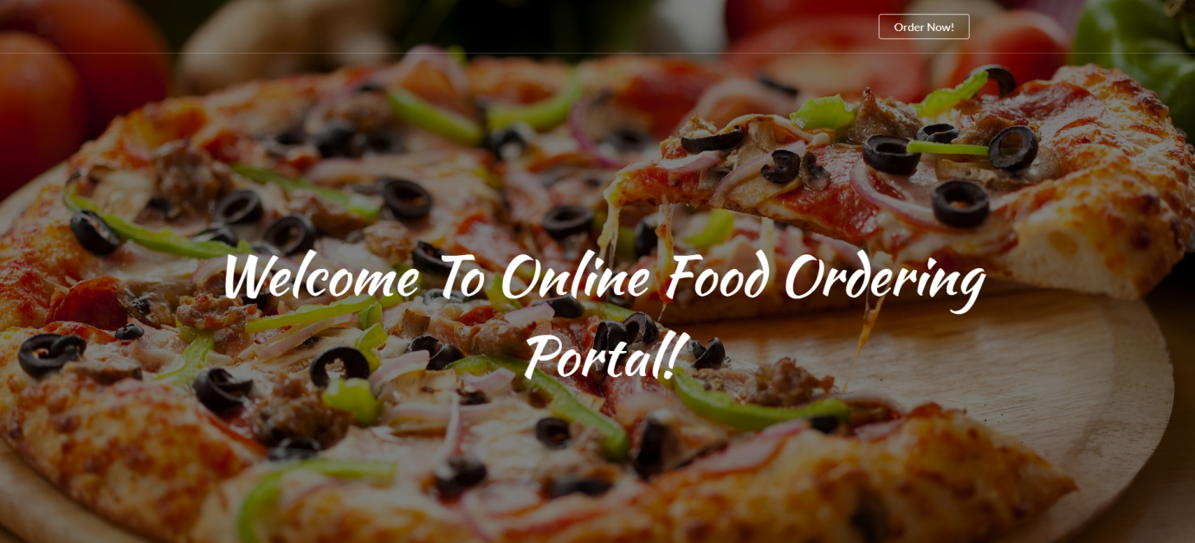

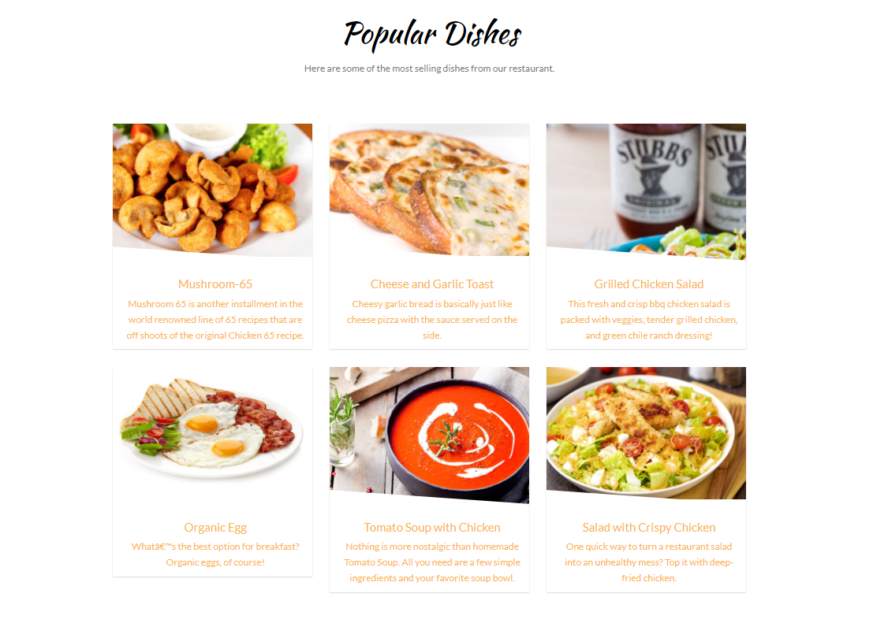

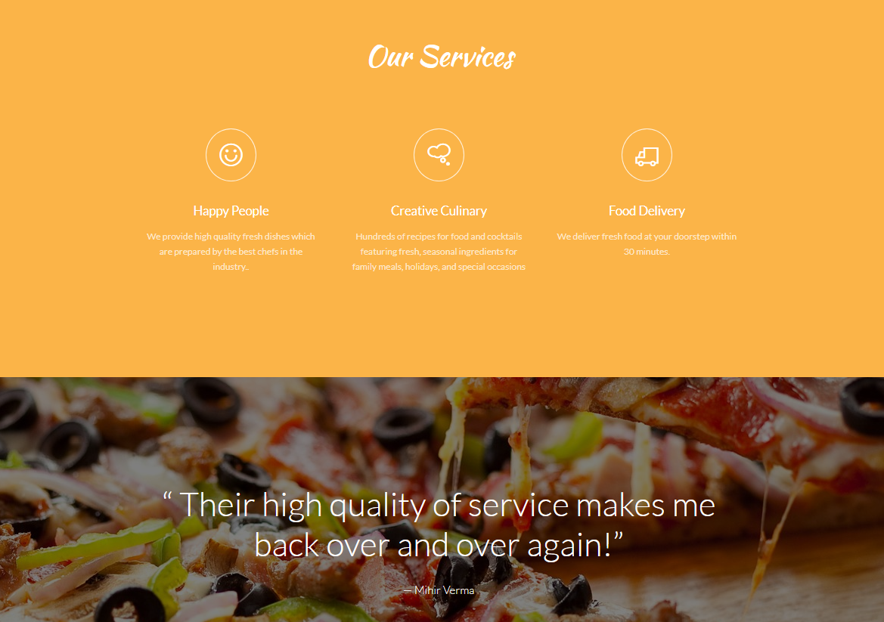

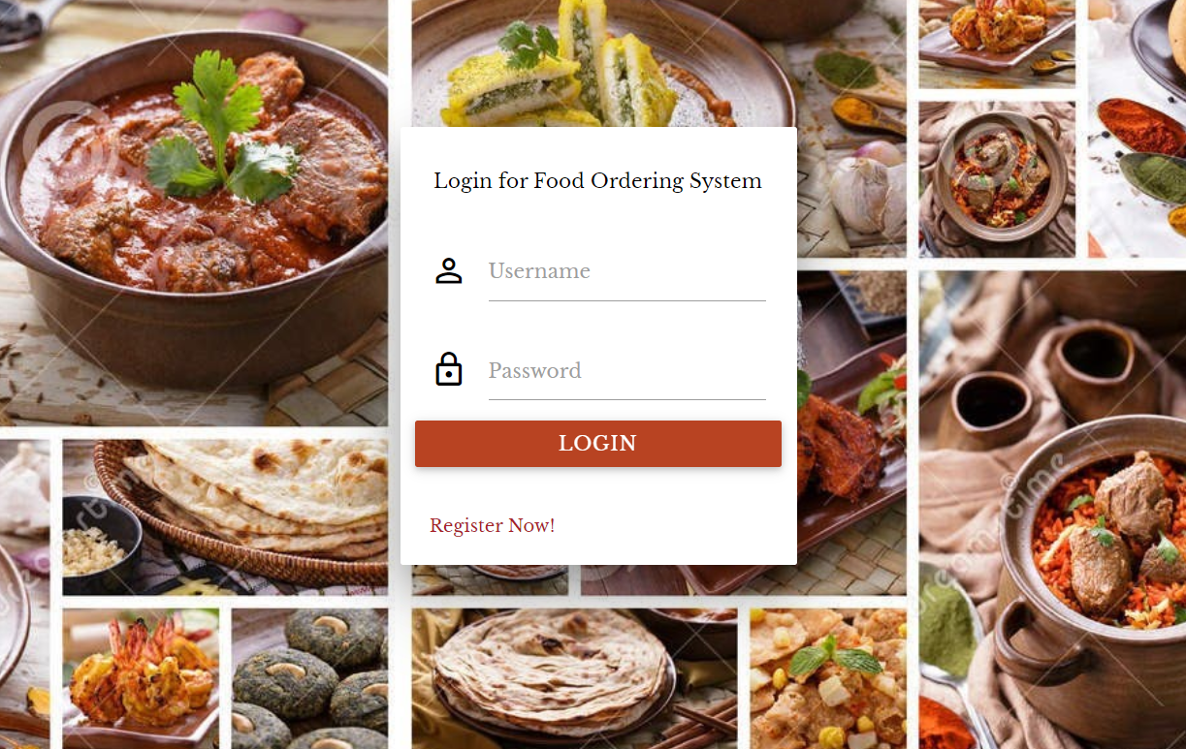

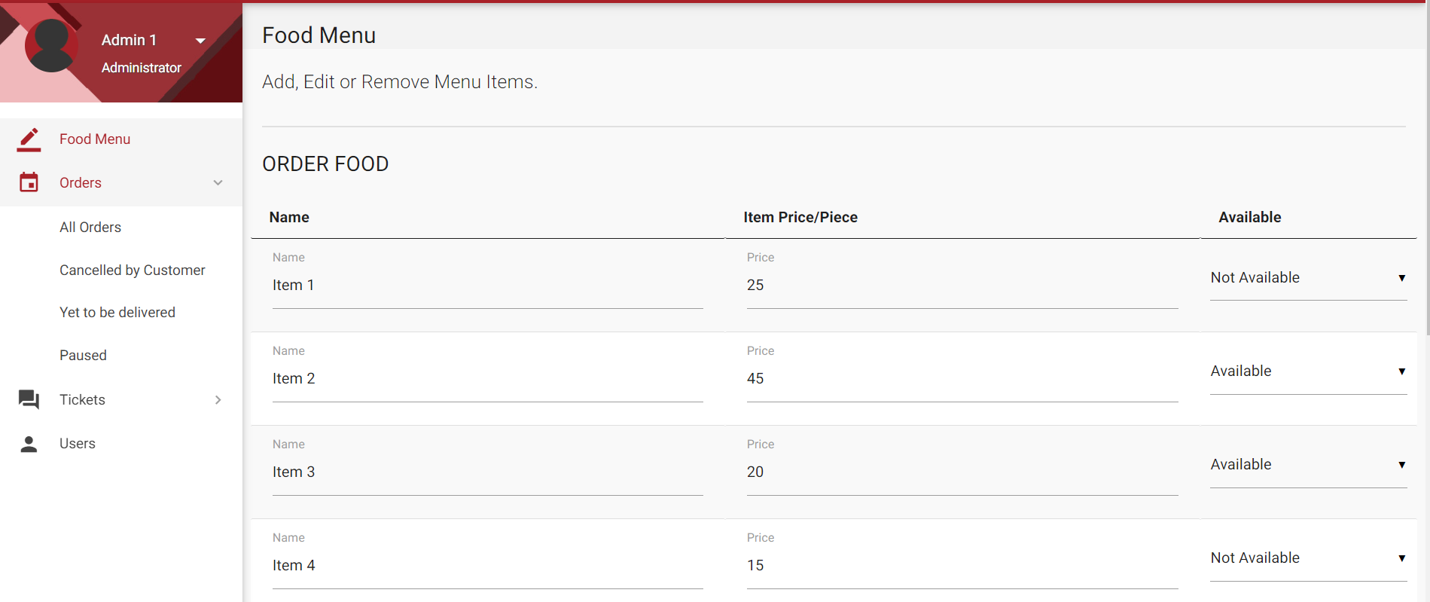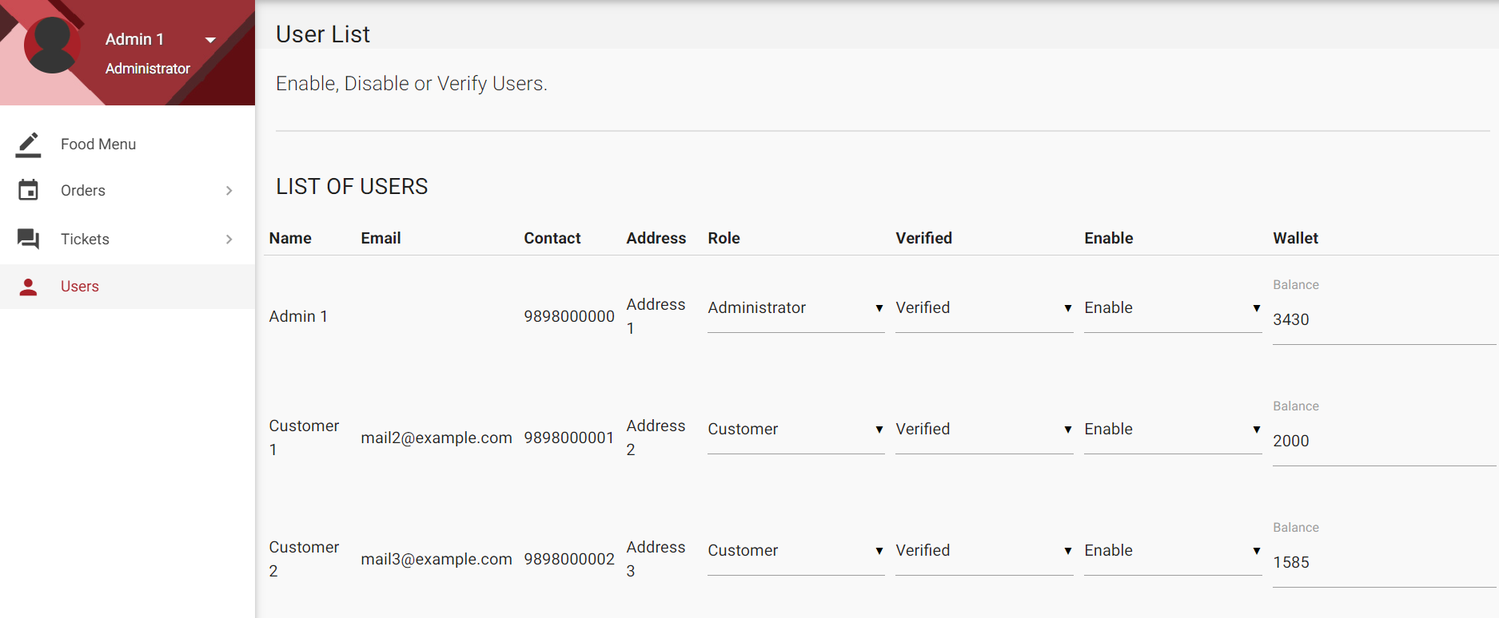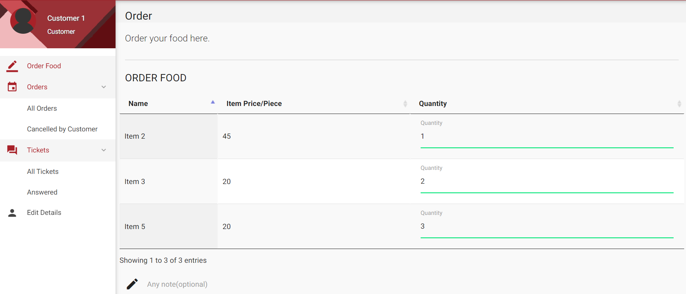

Conclusion And Future Work

* The project successfully implemented an Online Food Ordering Web Application which can be deployed and used for ordering the food online

.

* The future work will comprise of adding security certificates to the project.
* It will also include implementation and integration of different Payment Gateways like PayU Money, Payzapp, Razorpay etc.
* Moreover, future work will include a Live Chat Support for the customers. A ChatBot will be deployed to respond and resolve customer issues.

References

1. **The Joy of PHP Programming: A Beginner’s Guide to Programming Interactive Web Applications with PHP and MySQL**
2. **HTML and CSS: Visual QuickStart Guide (8th Edition) (Visual Quickstart Guides.**
3. **Head First! PHP and MySQL- O’Reilly**